Dear Parent/Carer
Can we interest you in the role of Parent Governor?
At Victoria Primary and Ebor Gardens, we are looking for a parent governor to join our governing body. Parent Governors bring an important, local perspective to Governing Body discussions and decision making and are key to successfully gathering a group of diverse people who all want the same thing – great schools for great children.
The three key roles of a GB in any school/academy are to:
• ensure that it has a clear vision, ethos, and strategic direction
• oversee the financial performance of the school/academy
• monitor the educational performance of the school/academy.
If you feel you could give up some time to undertake the role and would like to find out more about what it involves, please contact Sam Corbett, Governance Manager for Wellspring Academies Trust. Sam is contactable on 01226 720741 or by email s.corbett@wellspringacademies.org.uk. Sam will also talk you through the application process, which is very straightforward. The closing date for applications is Friday 1st October 2021.
Like any school or academy, having committed Governing Body members is extremely important and we very much look forward to hearing from you.
Why not give it a go?
Best wishes
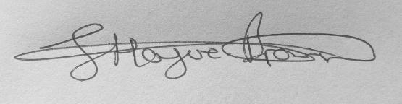
Sam Bailey Ian Bennett Hague-Brown
Executive Principal Chair of Governors

